NEWBERRY UNION:

A Portion of the Newberry Union Boundary

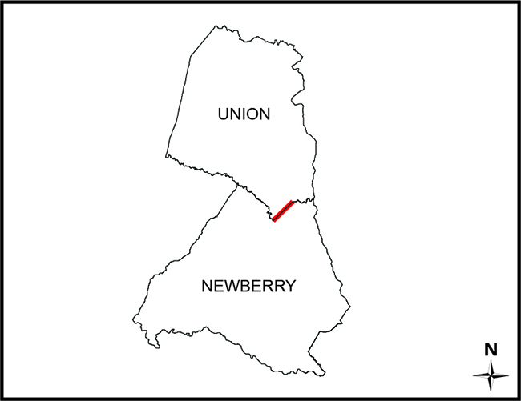

SC Code of Law: (http://www.scstatehouse.gov/code/t04c003.php)

SECTION 4-3-410. Newberry County.

“…thence down Enoree River to Anderson's Ford; thence along the road to Hill's Ferry on Tyger River …”

SECTION 4-3-500. Union County.

“…the Enoree River, down to Avery’s Ford; thence by the road to Crenshaw’s Ford, on the Tyger River…”

Re-establishment Survey:
- Draft Report (South Carolina - Newberry-Union - Draft Report - 2019.pdf)
- PowerPoint Presentation ((Dist) SCGS Public Newberry-Union County Boundary - 2019.pptx)
- Draft of Survey (Newberry Union draft 08-12-2019.pdf)

Historical and Reference Documents:

- 1820/1825 Newberry District (Newberry Mills (pen and ink).jpg) Mills, Robert, and Marmaduke Coate. Newberry District, South Carolina. [1820] Map. Retrieved from the Library of Congress, <https://www.loc.gov/item/2007627689/>
- 1820/1825 Union District (Union Mills.jpg) Mills, Robert, and R. Thompson. Union District, South Carolina. [1825] Map. Retrieved from the Library of Congress, <https://www.loc.gov/item/2007627924/>.
- Blanche H. Cudd Tract (58) (Cudd Tract 58.pdf) Map Titled “Enoree Purchase Unit, Land of Blanche H. Cudd Number 58”; Surveyed by A.L. Glen & Party, Dated July 1934; Description Included.
- George S. Mower Estate Tract (150) (Mower Tract 150.pdf) Map Titled “Enoree Purchase Unit, Land of George S. Mower Estate Number 150”; Surveyed by A.L. Glen & Party, Dated August 1934; Description Included.
- Mrs. Carrie A. Shouse Tract (275) (Shouse Tract 275.pdf) Map Titled “Enoree Purchase Unit, Land of Mrs. Carrie A. Shouse, etal Numbers 275 a, b”; Surveyed by A.L. Glen & Party, Last Revised April 18, 1936; Description Included.
- Nannie Belle Eison Tract (278) (Eison Tract 278.pdf) Map Titled “-Sumter- Enoree District, Land of Nannie Belle Eison Tract No. 278”; Surveyed by A.L.G. & Party, Dated Nov. 1934; Description Included.
- W.N. Glymph Tract (291) (Glymph Tract 291.pdf) Map Titled “-Sumter- Enoree District, Land of W.N. Glymph #291”; Surveyed by A.L. Glen & Party, Dated 1935-1938; Description Included.
- 1935 Glymph Map (Glymph 1935.pdf) Map of “The Land of D.W.N. Glymph” Surveyed February 5, 1935.
- 1838 Clark Map (Clark 1838.pdf) Map Containing 307 Acres in Newberry and Union Districts, Being a Part of the Land of George Clark; Surveyed December 1838.
- Newberry Plat Book ‘AY’ page 129 (AY-129.pdf) Survey For “Boise Cascade Timberlands, Roberts Tract” by Freeland & Associates; dated July 20, 1981 and Recorded in the Office of the Register of Deeds for Newberry County in Plat Book ‘AY’, page 129.
- Newberry Plat Book ‘AL’ page 49 (AL-49.pdf) Map of “M.E. Abrams Land”; Surveyed Dec. 13, 1939, by J.R. Crawford; Copied May 14, 1969 by Dan E. Collins and Recorded in Newberry County in Plat Book ‘AL’ page 49.
- Newberry Plat Book ‘AB’ page 51 (AB-51.pdf) Survey of “Lucy Frances A. Lorick Tract”, by Dan E. Collins, Last Revised May 15, 1969 and Recorded in Newberry County in Plat Book ‘AB’ page 51; Union County in Plat Book ‘14’, page 158.
- Newberry Plat Book ‘U’ page 75 (U-75.pdf) Survey of “That Part of Pettus W. Chicks Home Place, Lying on the South West Side of the State Road Between Tyger and Enoree Rivers”, by J.R. Renwick, dated November 29, 1883; Copied December 22, 1964 and Recorded in Newberry County in Plat Book ‘U’ page 75.
- Newberry Plat Book ‘H’ page 6 (H-6.pdf) Plat by E.O. Counts, dated January 20, 1934 of a Combination of 3 Plats, Surveyed in 1853, 1875, and 1899 and Recorded in Newberry County in Plat Book ‘H’ page 6.
- James Crenshaw Tract (Crenshaw James 1809 697 ac.pdf) Map of 697 Acres for James Crenshaw, Surveyed November 17, 1809.
- John Gordon Tract (Gordon John 1750 450 ac.pdf) Map of 450 Acres for John Gordon, Dated August 7, 1750.
- John Valentine Tract (Valentine John 1807 112 ac.pdf) Map of 112 Acres for John Valentine, Surveyed August 11, 1807.
- Govin Gordon Tract (Gordon Govin 1794 43 ac.pdf) Map of 43 Acres for Govin Gordon, Surveyed October 17, 1794.
- John Towns Tract (Towns John 1769 200 ac.pdf) Map of 200 Acres for John Townes, Dated May 23, 1769.
- Alexius Mador (Forster Alexius Mador 1775 150 ac.pdf) Map of 150 Acres for Alexius Mador, Dated June 14, 1775.
- Samuel Awberry Tract (Awbery Samuel 1763 100 ac.pdf) Map of 100 Acres for Samuel Awberry, Dated January 19, 1763.
- Phillip Auberry Tract (Auberry Phillip 1785 480 ac.pdf) Map of 480 Acres for Phillip Auberry, Dated August 10, 1785.
- John L. Lyles Tract (Lyles 1878.pdf) Map of 183 Acres for John L. Lyles, by G.M. Girardeau, Surveyed January 23, 1878.

Monuments: (See Draft Plat for Geographic Coordinates of Monuments)
- 1: Enoree River (1 Mon 1 (Enoree).jpg)
- 2: USFS Property Corner 10, Tract 291 (2 Mon. 2.jpg and 2-1 Mon. 2.1.jpg)
- 3: USFS Property Corner 12, Tract 291 (3 Mon. 3.jpg and 3-1 Mon. 3.1.jpg)
- 4: 16” Sweet Gum; USFS Property Corner (4 Mon. 4.jpg)
- 5: 1” Rebar w/Cap Set (5 Mon. 5.jpg and 5-1 Mon. 5.1.jpg)
- 7: 1” Rebar w/Cap Set (7 Mon. 7.jpg and 7-1 Mon. 7.1.jpg)
- 8: 1” Rebar w/Cap Set (8 Mon. 8.jpg and 8-1 Mon. 8.1.jpg)
- 10: 1” Rebar w/Cap Set (10 Mon. 10.jpg and 10-1 Mon. 10.1.jpg)
- 13: 1” Rebar w/Cap Set (13 Mon. 13.jpg and 13-1 Mon. 13.1.jpg)
- 16: 24” Pine; USFS Property Corner (16 Mon. 16.jpg and 16-1 Mon. 16.1.jpg)
- 17: 1” Rebar w/Cap Set (17 Mon. 17.jpg and 17-1 Mon. 17.1.jpg)
- 18: 2”x1-1/2” Concrete Monument (18 Mon. 18.jpg and 18-1 Mon. 18.1.jpg)
- 19: 1-1/2” Pinched Pipe (19 Mon. 19.jpg and 19-1 Mon. 19.1.jpg)
- 20: 1-1/2” Pinched Pipe (20 Mon. 20.jpg)
- 21: 1-1/2” Pinched Pipe (21 Mon. 21.jpg and 21-1 Mon. 21.1.jpg)
- 22: 1-1/2” Pinched Pipe (22 Mon. 22.jpg and 22-1 Mon. 22.1.jpg)
- 23: 1-1/2” Pinched Pipe (23 Mon. 23.jpg and 23-1 Mon. 23.1.jpg)
- 25: 1” Rebar w/Cap Set (25 Mon. 25.jpg and 25-1 Mon. 25.1.jpg)
- 26: 1” Rebar w/Cap Set (26 Mon. 26.jpg and 26-1 Mon. 26.1.jpg)
- 27: Tyger River ()

The Revenue and Fiscal Affairs Office is providing access to these materials for educational and research purposes and is not aware of any U.S. copyright protection (see Title 17 of the United States Code) or any other restrictions in the provided materials.\
Note that the written permission of the copyright owners and/or other rights holders (such as publicity and/or privacy rights) is required for distribution, reproduction, or other use of protected items beyond that allowed by fair use or other statutory exemptions. Responsibility for making an independent legal assessment of an item and securing any necessary permissions ultimately rests with persons desiring to use the item.

