GEORGETOWN HORRY:

A Portion of the Georgetown Horry Boundary

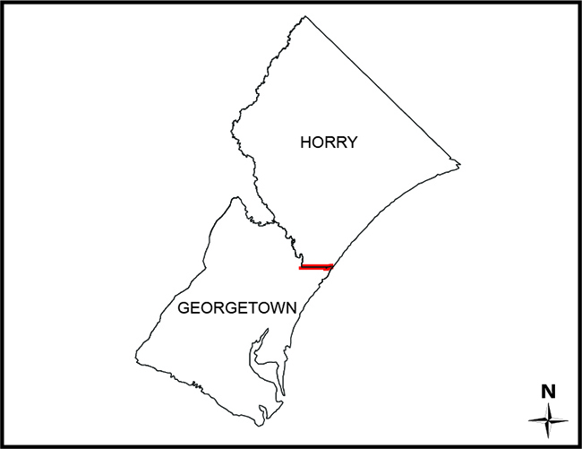

SC Code of Law: (http://www.scstatehouse.gov/code/t04c003.php)

SECTION 4-3-270. Georgetwon County.

“…center line of the Waccamaw River to a point at latitude 33° 34' 22.623" N, longitude 79° 06' 03.848" W (North American Datum 1983); thence eastward following a straight line to a point at latitude 33° 34' 21.602" N, longitude 79° 00' 06.564" W (North American Datum 1983) on the seashore; thence on a true azimuth of 126° (bearing of S 54° E) to the Territorial Sea boundary…”

SECTION 4-3-310. Horry County.

”… center line of the Waccamaw River to a point at latitude 33° 34' 22.623" N, longitude 79° 06' 03.848" W (North American Datum 1983) in the Waccamaw River; thence eastward following a straight line to a point at latitude 33° 34' 21.602" N, longitude 79° 00' 06.564" W (North American Datum 1983) on the seashore; thence on a true azimuth of 126° (bearing of S 54° E) to the Territorial Sea boundary…”

SECTION 4-3-311. Defined area of Georgetown County annexed by Horry County.

”…Beginning at the intersection of the Horry-Georgetown County line and the canal which runs from Horry County into Georgetown County to the intersection of Murrells Inlet Creek, thence northeasterly along the center line of Murrells Inlet Creek to its intersection with the Horry-Georgetown County line…This tract measures and contains 18.42 acres of land, more or less, and is clearly shown on a plat by William F. Cox, William N. Kellahan, Jr., and Samuel H. Hanna III, dated July 19, 2002, and filed with the Secretary of State on August 15, 2002…”

2019 Annexation Survey:
- Certified Survey (2019 Geor Horr Annexation.pdf)
- Executive Order 2019-23 (2019-08-26 FILED Executive Order No. 2019-23 - Horry-Georgetown Annexation Election.pdf)
- Link to GIS Map (Will Roberts will Supply)

Historical and Reference Documents: (See Certified Plat for Additional References)
- Act 302 of 1992 (https://www.scstatehouse.gov/sess109_1991-1992/bills/984.htm)
- Act 36 of 2003 (https://www.scstatehouse.gov/sess115_2003-2004/bills/3906.htm)
- 2002 Annexation Plat (Annexation Plat Horry Georgetown August 2002.pdf) SURVEY OF THAT PORTION OF MT. GILEAD DEVELOPEMT SITUATED IN GEORGETOWN COUNTY FOR THE COMMISSION APPOINTED BY THE GOVERNOR OF SOUTH CAROLINA TO INVESTIGATE PROPOSED ANNEXATION INTO HORRY COUNTY, SURVEY AND PLAT BY LOWER FLORENCE COUNTY SURVEYING, DATED JULY 9, 2002, ON FILE WITH THE SECRETARY OF STATE’S OFFICE.

Monuments: (See Certified Plat for Geographic Coordinates of Monuments)

The Revenue and Fiscal Affairs Office is providing access to these materials for educational and research purposes and is not aware of any U.S. copyright protection (see Title 17 of the United States Code) or any other restrictions in the provided materials.\
Note that the written permission of the copyright owners and/or other rights holders (such as publicity and/or privacy rights) is required for distribution, reproduction, or other use of protected items beyond that allowed by fair use or other statutory exemptions. Responsibility for making an independent legal assessment of an item and securing any necessary permissions ultimately rests with persons desiring to use the item.

