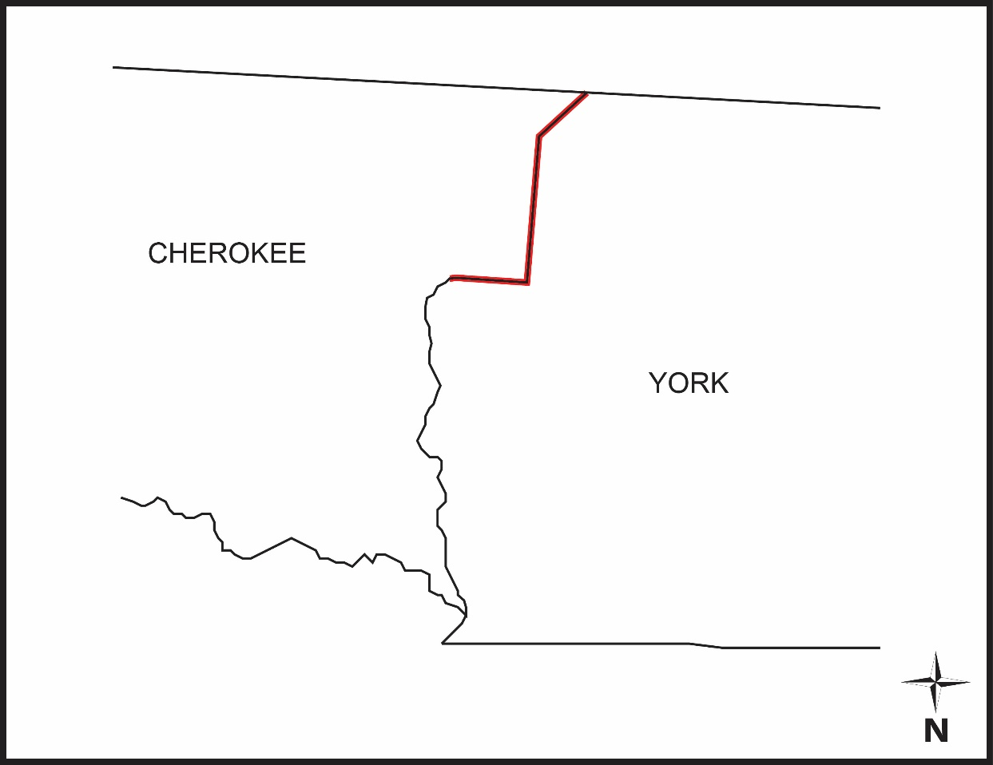
Cherokee York Boundary

SC Code of Law: (http://www.scstatehouse.gov/code/t04c003.php)

SECTION 4-3-110. Cherokee County.
Cherokee County is bounded as follows: “…thence with said line crossing Broad River, and continuing at the corner of Cherokee township in York County; thence south with east boundary of said township to stake; thence west to corner of said township on King's Creek; thence down King's Creek to middle of Broad River; thence down Broad River to center of river opposite Pacolet River; thence up Pacolet River to opposite Brown's Branch to beginning point, and in addition thereto the following territory containing two square miles transferred from York County by act of the General Assembly, approved February 11 1921, to wit: beginning at a stake in road in State line on top of mountain at Burned Grocery and running thence S. 43.5° W. 224 chains to a large pine at northeast end of Brown Mountain; thence with the Cherokee County line N. 2.5° W. 152 chains to B. O., E. A. Patterson's corner in State line; thence S. 86° E. 165 chains with State line to the beginning corner, containing two square miles…”
SECTION 4-3-530. York County.

“…on the west by the eastern line of Cherokee County, mentioned in 4-3-110…” “…less the following territory transferred to Cherokee County by act of the General Assembly, approved February 11 1921, to wit: beginning at a stake in a road in the State line on top of a mountain at Burned Grocery and running thence S. 43 1/2 ° W. 224.00 chains to a large pine at the northeast end of Brown's Mountain; thence with the Cherokee County line N. 2 1/2 ° W. 152.00 chains to now or formerly B. O., E. A. Patterson's corner in the State line; thence S. 86° E. 165.00 chains with the State line to the beginning corner containing two square miles. The metes and bounds and location and lines are more accurately set forth on a plat bearing the name of A. P. Falls, surveyor, filed in the office of the Governor…”

Re-establishment Survey:
- PowerPoint Presentation (Website Cherokee – York County Line.pptx)
- Draft Plat of Survey (York Cherokee draft 04-14-2017.pdf)

Historical and Reference Documents:
- Map of York County (1910 York County Map.tif) Jones and Walker. York County, South Carolina dated 1910. Map.
- 1919-1920 Petition to the Governor (1919 Petition to Governor.pdf) Petition to Governor Robert A. Cooper. Provided by the South Carolina Department of Archives and History. (S166001)
- 1920 Report of Commissioners (1920 Annexation Commissioners Report.pdf) Annexation of Part of York County to Cherokee County dated July 15, 1920. Provided by the South Carolina Department of Archives and History. (File No. 69; Governor’s Office; County Annexation)
- 1920 Annexation Map (1920 Annexation Map (York 37 Pg 130).pdf) Faires, I.B.; Falls, A.P.; and Stacy, John L.; Map of part of York County… cut off and annexed to Cherokee County dated May 28-29 and June 1-2, 1920. Map. Recorded in the office of the Register of Deeds for York County in Plat Book 37, page 130.
- 1920 Annexation Map (1920 Annexation Map (Ch U Pg 311).pdf) Faires, I.B.; Falls, A.P.; and Stacy, John L.; Map of part of York County… cut off and annexed to Cherokee County dated May 28-29 and June 1-2, 1920. Map. Recorded in the office of the Register of Deeds for Cherokee County in Plat Book U, page 311.
- 1922 Proposed Annexation (The 1868 Township Law West.pdf) West, Robert Jerald L. The 1868 Township Law and York County, South Carolina, 1996. Broad River Basin Historical Society, Provided by the York County Library.
- 1971 Grover Quadrangle (NC_Grover_162548_1971_24000_geo.pdf)
- 1971 Kings Creek Quadrangle (SC_Kings Creek_261191_1971_24000_geo.pdf)
- 1906 Kings Mountain Quadrangle (SC_Kings Mountain_261883_1906_62500_geo.pdf)

Monuments: (See Draft Plat for Geographic Coordinates of Monuments)
- 1” Rebar w/ Cap: Set (Set Rebar CherYork.pdf)
- Nail and Washer: Set (Set Pub Nail and Washer.pdf)
- 4: “Large Stone” (Large Stone.jpg)
- 5: 3/4” Pipe in Stone Pile (IP in Stone Pile.JPG)

The Revenue and Fiscal Affairs Office is providing access to these materials for educational and research purposes and is not aware of any U.S. copyright protection (see Title 17 of the United States Code) or any other restrictions in the provided materials.\
Note that the written permission of the copyright owners and/or other rights holders (such as publicity and/or privacy rights) is required for distribution, reproduction, or other use of protected items beyond that allowed by fair use or other statutory exemptions. Responsibility for making an independent legal assessment of an item and securing any necessary permissions ultimately rests with persons desiring to use the item.

