ABBEVILLE ANDERSON:

Abbeville Anderson Boundary

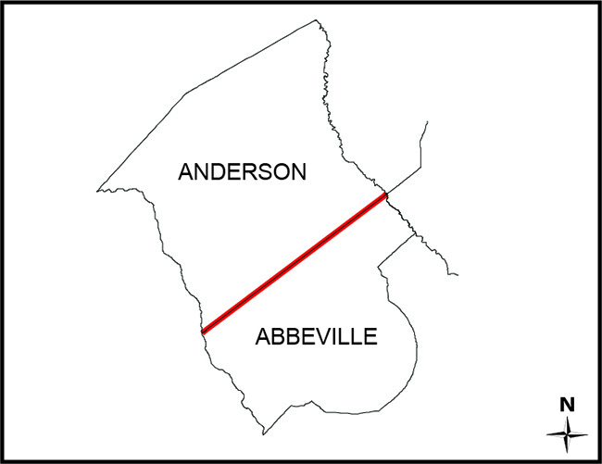

SC Code of Law: (http://www.scstatehouse.gov/code/t04c003.php)

SECTION 4-3-10. Abbeville County.

“…on the southwest by the Savannah River, by which it is separated from Georgia; on the northwest by Anderson County, from which it is separated by a line (the old Indian boundary) drawn from a marked black gum, on the east bank of the Savannah River, at the foot of Grape Shoals, N. 50° E. to a willow oak, marked "A. & P.," on the south side of Saluda River…”

SECTION 4-3-40. Anderson County.

“…on the southeast by Abbeville County, from which it is divided by a line drawn from a marked black gum on the east bank of the Savannah River, at the foot of Grape Shoals, to a willow oak, marked "A. & P.," on the south side of the Saluda River; on the southwest by the state of Georgia, from which it is separated by the Savannah River…”

Re-establishment Survey:
- Draft Report (South Carolina - Abbeville-Anderson - Draft Report - 2018 - Images - Revised 2018-9-19.pdf)
- PowerPoint Presentation (SCGS 9-19-2018 Abbeville-Anderson County Line (Public).pptx)
- Draft of Survey (Anderson Abbeville draft 09-06-2018.pdf)

Historical and Reference Documents:

Monuments: (See Draft Plat for Geographic Coordinates of Monuments)
- 1: 1” Rebar w/Cap Set (Picture1.jpg)
- 2: Stone beside ¾” Square Bar Found (Picture2.jpg)
- 3: Granite Monument Found (Picture3.jpg)
- 4 and 4a: Stone with “X” Found (Picture4.jpg and Picture4a.jpg)
- 5: Stone with 3/4" Pipe Witness Found (Picture5.jpg)
- 6: 1” Pipe in Stone Pile Found (Picture6.jpg)
- 7: 1” Pipe Found (Bent) (Pictue7.jpg)
- 8: Stone with 1" Pipe Witness Found (Picture8.jpg)
- 9: 1-1/2” Rod Found (Picture9.jpg)
- 10: 1/2" Rod Found (Bent) (Picture 10.jpg)
- 11: Stone Found at 36” Oak (Picture11.jpg)
- 12: 1” Pipe Found (Picture12.jpg)
- 13: 1” Pipe Found (Picture13.jpg)
- 13A: Mag Nail and Washer Set (Picture13A.jpg)
- 14: Mag Nail and Washer Set (Picture14.jpg)
- 14A: 1” Rebar w/Cap Set (Picture14A.jpg)
- 15: 3/4" Pipe Found (Picture15.jpg)
- 16: 1” Rebar w/Cap Set (Picture16.jpg)

The Revenue and Fiscal Affairs Office is providing access to these materials for educational and research purposes and is not aware of any U.S. copyright protection (see Title 17 of the United States Code) or any other restrictions in the provided materials.\
Note that the written permission of the copyright owners and/or other rights holders (such as publicity and/or privacy rights) is required for distribution, reproduction, or other use of protected items beyond that allowed by fair use or other statutory exemptions. Responsibility for making an independent legal assessment of an item and securing any necessary permissions ultimately rests with persons desiring to use the item.

