Frequently Asked Questions regarding the
Re-established Boundary between North and South Carolina

- Why did South Carolina and North Carolina re-establish the state line?

When jurisdictional issues arose along the state boundary between York County, SC and Gaston County, NC in the early 1990s, the SC Geodetic Survey and the NC Geodetic Survey signed a Memorandum of Agreement in April 1993 to cooperatively re-establish the South Carolina – North Carolina boundary. The intent was to avoid a litigious dispute, such as occurred between South Carolina and Georgia regarding their boundary in the Lower Savannah River area. That contentious dispute cost the South Carolina $10 million and 26 years of litigation and negotiation, that involved the U.S. Supreme Court and Congress, to resolve 25 miles of boundary.

- Who was responsible for re-establishing the state line?
The South Carolina Geodetic Survey and North Carolina Geodetic Survey were responsible for technically re-establishing the boundary. A NC-SC Joint Boundary Commission was created to oversee and approve the technical work, and the efforts to reduce or eliminate impacts on property owners affected by the re-established boundary. The commission comprised members from the South and North Carolina Geodetic Surveys, senators and representatives from both states’ legislatures, representatives from both states’ Attorney General Offices, and state agency personnel.
- Why can’t we leave the boundary where it is? How and why did the boundary “move?”
The South Carolina Code of Laws defines South Carolina’s boundary. The boundary has not “moved.” When creating these local maps, adjacent jurisdictions have used differing resources that have caused gaps, overlaps and inaccurate plotting of the States common boundary, which has led to confusion.
The boundary between South and North Carolina was created by five surveys between 1735 and 1815 (refer to map below). The first survey began in 1735 and ended in 1737. The second, third, fourth and fifth occurred in 1764, 1772, 1813, and 1815, respectively. Two hundred years have elapsed since these surveys were completed. Except for a few stone monuments set during the 1813 and 1815 surveys, the surveyors for the original surveys marked trees to locate the state line. As years passed, when “boundary trees” died or were cut down, neither state made the effort to maintain the boundary with new monuments, resulting in a dubious, unclear, South Carolina – North Carolina boundary.
The technical work to re-establish the boundary used copies of the original survey plats, historical research and extensive land record research to recover evidence that could be used to identify the location of the original boundary as best as possible. Monuments defining the re-established South Carolina – North Carolina are now defined by geographic and state plane coordinates; so that, if a monument is destroyed its position can be relocated using its mathematical coordinates, and conventional or GPS surveying techniques.

SURVEY HISTORY OF SOUTH CAROLINA – NORTH CAROLINA BOUNDARY
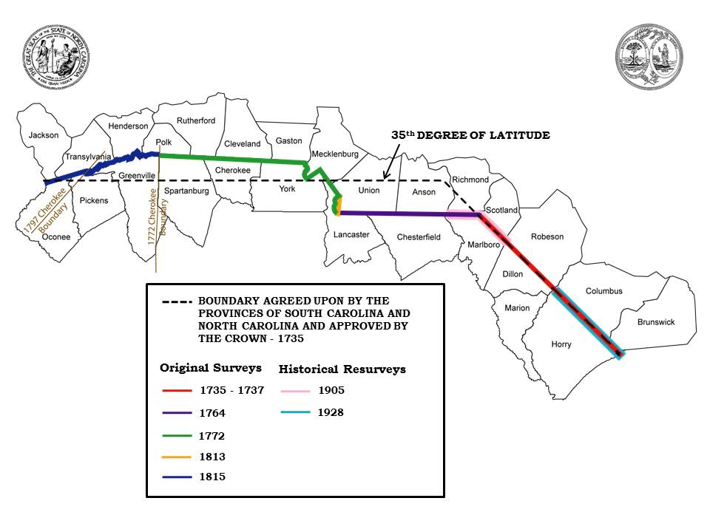
Signed and sealed survey plats were completed for the re-establishment of the state boundary have been recorded at each of the county’s Registry of Deeds Office and copies are available at the SC Department of Archives & History and the SC Geodetic Survey.
- What was the outcome of the re-established boundary?
The effort to technically re-establish the 334-mile-long South Carolina – North Carolina boundary started in 1995 was completed on May 3, 2013 when the NC – SC Joint Boundary Commission approved the technical work for the last 91 miles. There were approximately 1640 different parcels of property that were impacted with this project.

The SC and NC Attorney General Offices helped prepare legislation that was passed by the South Carolina and North Carolina legislatures. The legislation reduces and/or eliminates impacts to those property owners whose residency or business would move from South Carolina to North Carolina, or vice versa, because of the re-established state boundary. Results of the project include:

Residences Split _________________________________________________ 47
Residences Change States __________________________________________ 19
4 residences have moved from NC into SC
15 residences have moved from SC into NC
Commercial/Institutional Building Split ________________________________ 7
Commercial Change States __________________________________________ 2

- Residency of Individuals:
An individual whose state of residency changes as a result of the boundary clarification from North Carolina to South Carolina or from South Carolina to North Carolina must be treated as though the individual moved to or from South Carolina on January 1, 2017.
For businesses whose property location changes from North Carolina to South Carolina or from South Carolina to North Carolina as a result of boundary clarification, for income tax purposes, the property is treated as though the property moved into or out of South Carolina on January 1, 2017
- Impacted: Will I have to pay back taxes?
It is the intent of the General Assembly that when an individual’s residence or a business location is determined to be located in South Carolina rather than North Carolina, where the residence or business had previously been taxed, the individual or business should not be liable for back taxes to South Carolina solely as a result of the clarification.
Individuals whose residency or taxpayers whose property or business location is considered to have changed from North Carolina to South Carolina solely as a result of the boundary clarification, effective January 1, 2017, are not liable for any taxes for periods prior to the boundary clarification date based solely on a claim that the individual was a resident or the taxpayer’s property or business location was located in South Carolina in the prior year.
- Impacted: Can my children continue to attend the same school?
Upon the effective date January 1, 2017, persons residing on property which is determined to be located in North Carolina as a result of the boundary clarification, may enroll their children residing with them in the South Carolina district in which that property was previously believed to be located or in the statewide public charter school district, without charge, as long as the family maintains residence on that same property.
- Impacted: Utility Services?
Upon the effective date of January 1, 2017, property located in whole or in part in North Carolina immediately prior to that date and receiving utility service from a North Carolina utility as defined under North Carolina law, may continue to receive utility service from that utility or its successors although the property is determined to be located in whole or in part in South Carolina as a result of the boundary clarification. The owners of that property have the option of requesting utility service by a similar South Carolina utility if the property is located within that utility’s service area, regardless of whether the property is inside or outside a municipality.
- Impacted: Medicaid providers?
Medicaid provider, outside of the geographical boundary of South Carolina but within the South Carolina Medicaid Service Area, as defined by R. 126-300(B) of the Code of State Regulations, prior to January 1, 2017, shall not lose status as a Medicaid provider as a result of the clarification of the South Carolina - North Carolina border.” The South Carolina Medicaid Service Area is South Carolina and adjacent areas within twenty-five (25) miles of the SC border.
- Impacted: Trash? Recycle? First responder?

Registration for these services, if available, will be taken care of by the respective county officials once your new address has been established. If your mailing address is not changed, the services you were receiving should not change.

- Impacted: Voter Registration? Driver License? Vehicle Registration?
This can be accomplished when you apply for a new SC Driver’s License. This is done at the nearest SC Department of Motor Vehicle’s Office.
Any other questions or concerns you may have can be answered by using the internet and browsing to the SCIWAY – the South Carolina Information Highway or reaching out to the county assessor’s office. The URL for the South Carolina Information Highway is: www.sciway.net. The contact information for the county assessor’s offices is:
Cherokee County | 864-487-2552
Chesterfield County | 843-623-7362
Dillon | 843-774-1412
Horry | 843-915-5040
Lancaster | 803-285-6964
Marlboro | 843-479-5602
Spartanburg | 864-596-2544
York | 803-684-8526

