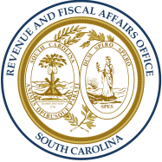
South Carolina Revenue and Fiscal Affairs Office
WWW.RFA.SC.GOV

LOCAL GOVERNMENT FISCAL IMPACT ESTIMATE
(Please return to sender)

Bill #: | County or Municipality: | Phone Number:
Date: | Estimate Prepared by: | Email Address:

SELECT ONE OF THE FOLLOWING:

 | A. | This bill will have no fiscal impact on my locality.
 | B. | This bill will result in a savings for my locality.
 | C. | My locality can absorb costs associated with this legislation.
 | D. | This bill will have a fiscal impact on my locality as follows:

Type of Expense | Recurring | Non-Recurring
Personnel Service
(include Employer Contributions)
Additional Number of Positions
Operating Costs
Other (specify)
Other (specify)
TOTAL

Background Information on Impact (ex: positions, titles, detail on operating costs, etc.):

Additional Notes and Comments:

